Original docket entry

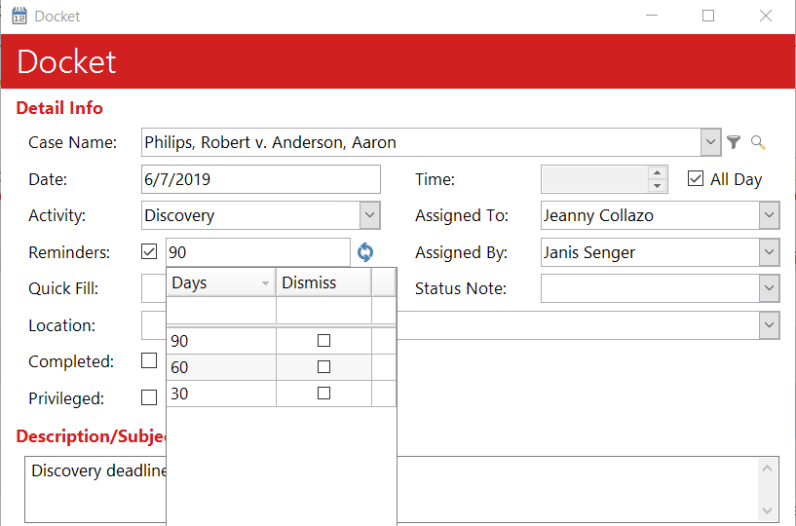

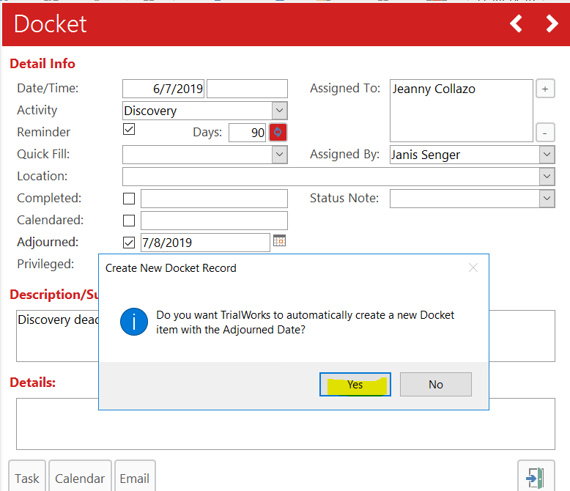

New Docket entry

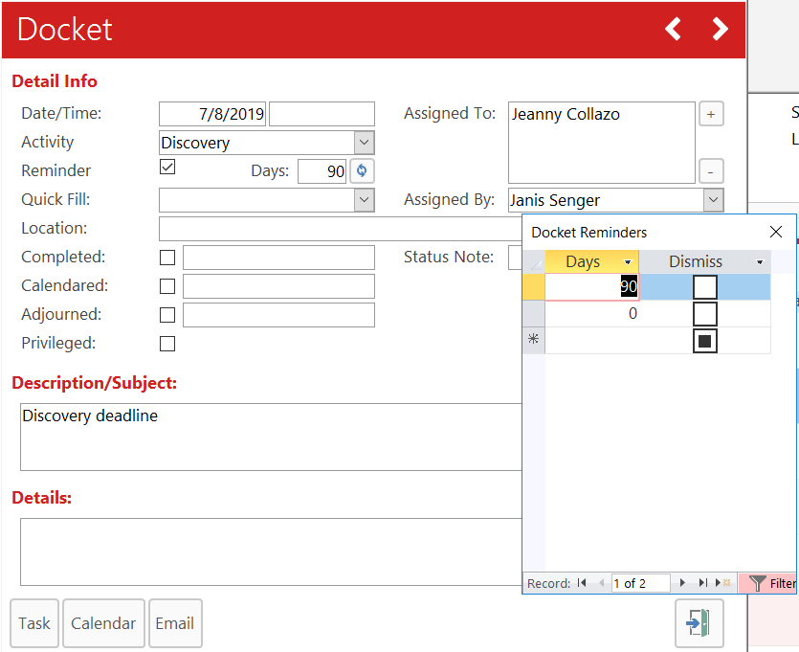

Even If I add the multiple reminders then send to OL only the first reminder invite is created. The additional reminders don’t get created in OL.